Name___________________________________

Dragon Project

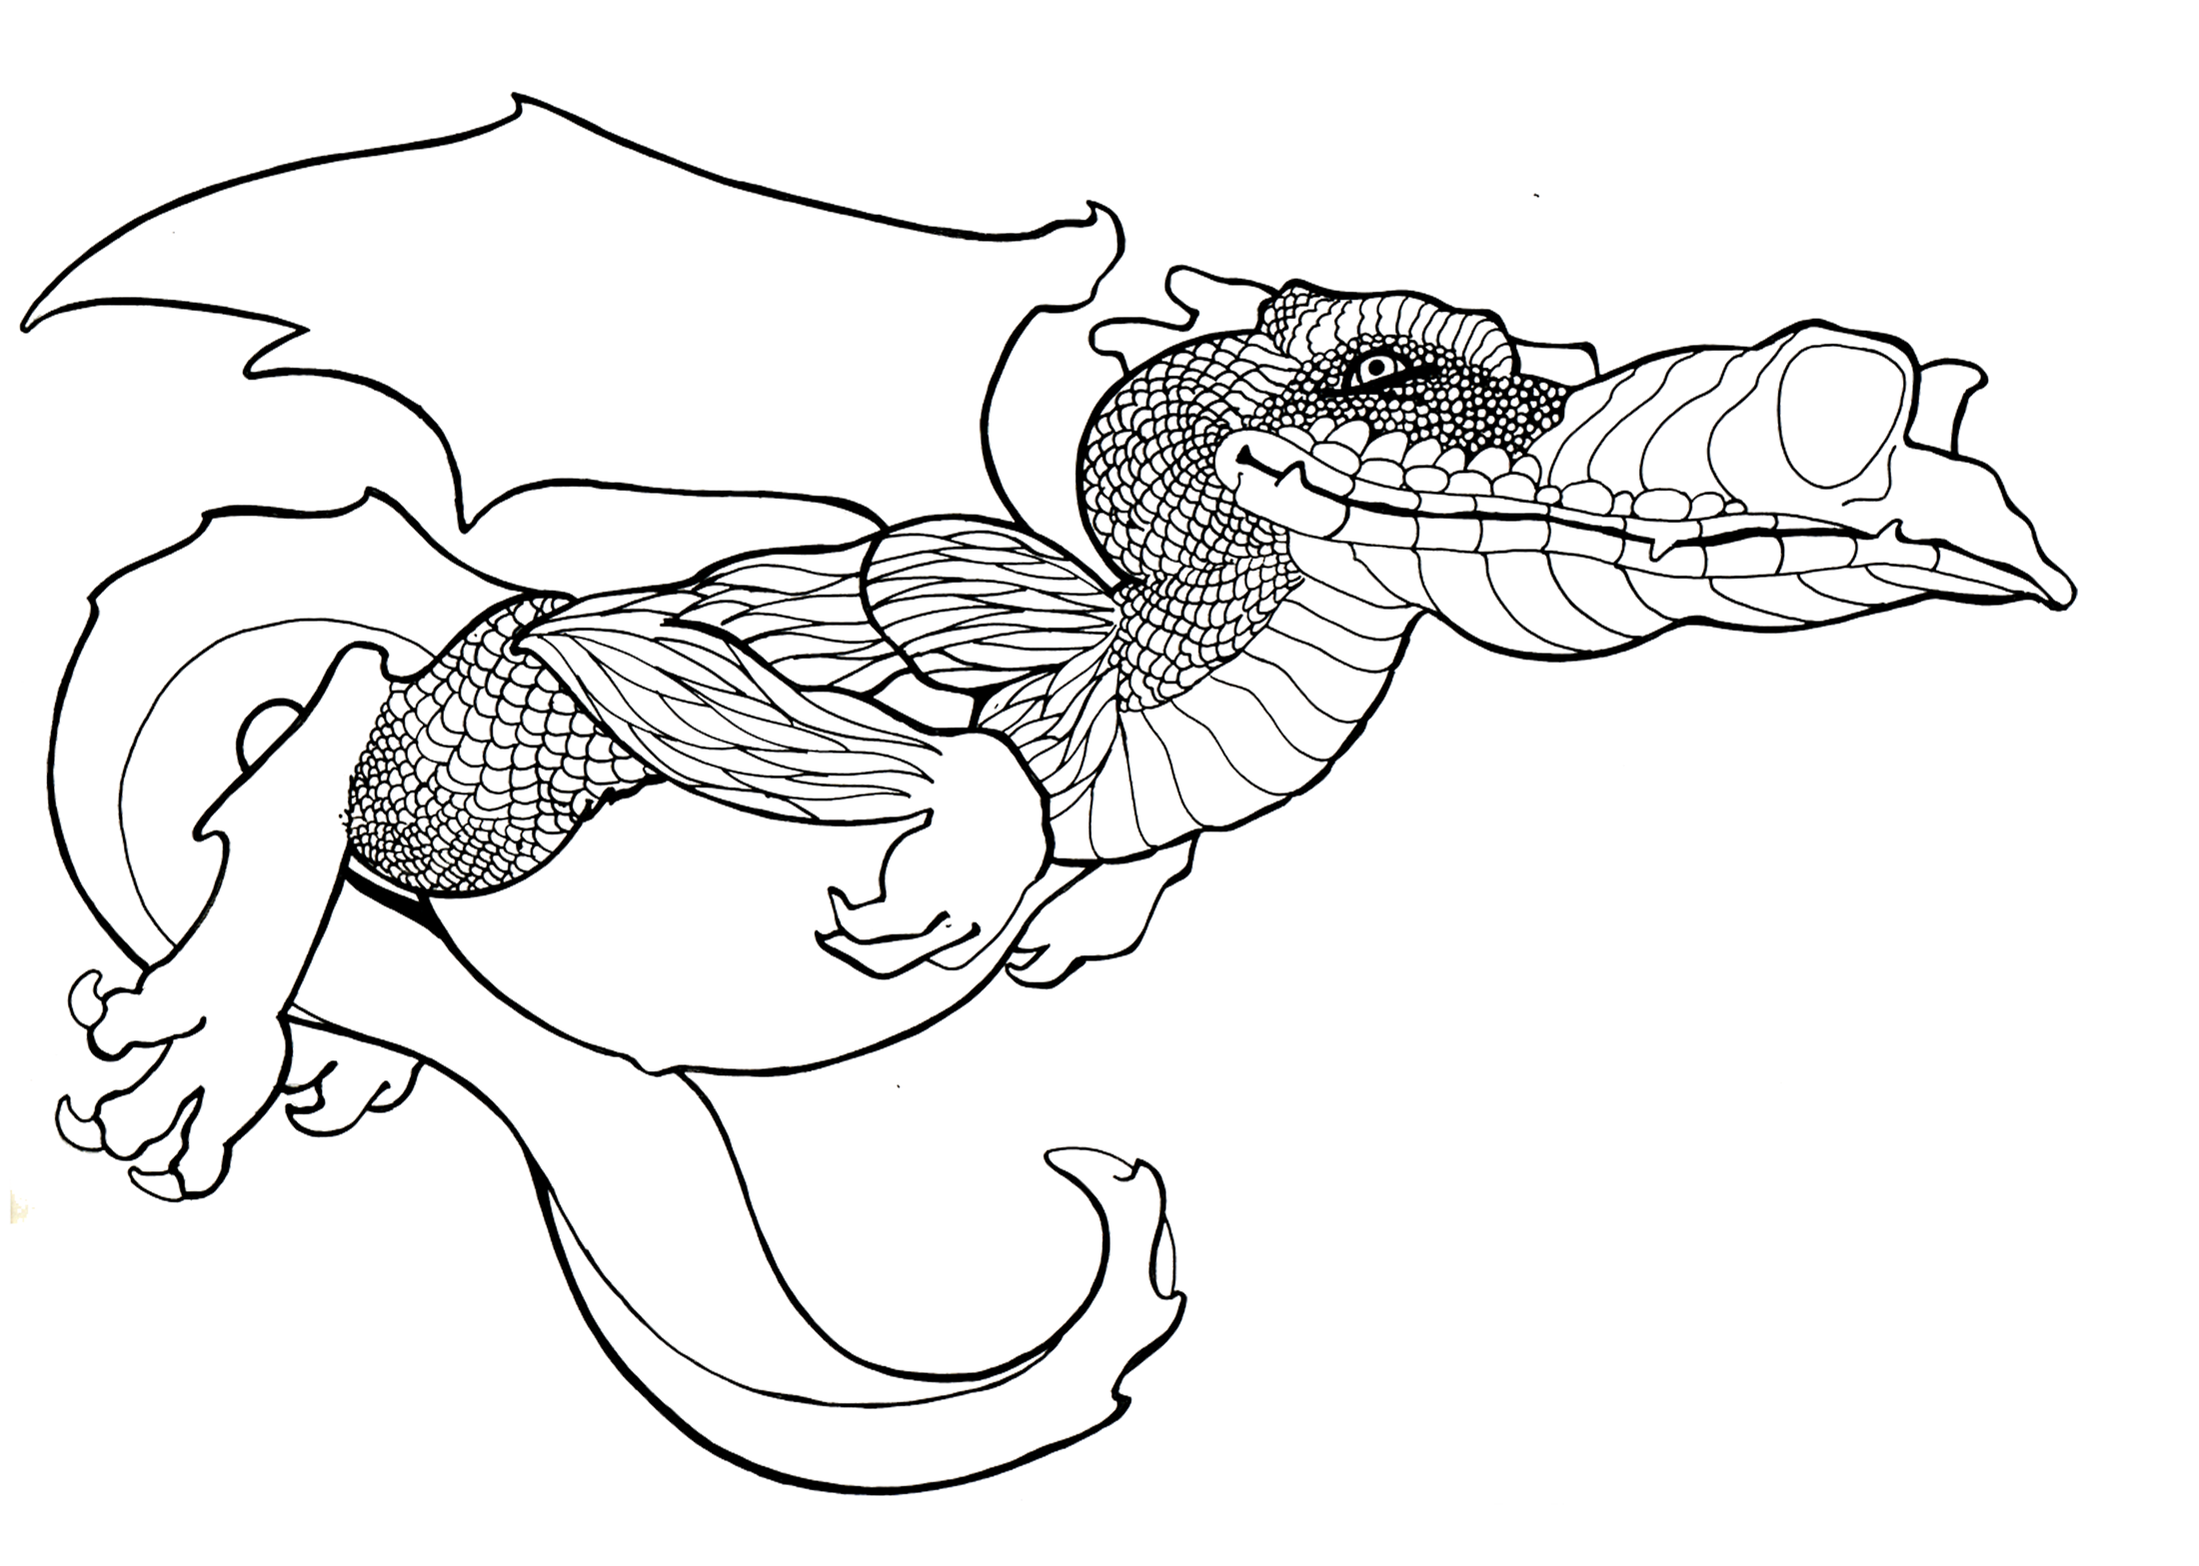

The purpose of the Dragon Project is to apply the Photoshop skills learned so far in class. The focus of this project is the skills of applying colors, gradients, effects, lighting and texture effects to layers. You want to make the dragon appear as 2 or 3 Dimensional as possible.

Steps
- Open the Dragon Master and save it to your area. Your Last NameFirst Initial Dragon
- Begin on the outline layer (Duplicate it so you have an original)
- Select a segment(s) on the Dragon
- Make a new layer via copy, name it with the body part. Make sure you also make use of groups (folders)
- Expand the selection
- Apply color, lighting and texture effects as appropriate
- Add shading using masking etc.
- Put name at bottom right corner. Make this part of the art.
- Print to color printer with this copy below it.

Be creative and have fun with this project. Take the time in the beginning to create a mental image of how the Dragon will look. You may choose any colors or textures that you want to use.

Evaluation points: 150 Points
  - Overall look of the Dragon – visual appeal (does it have depth via gradients and effects…do not overuse the blending options—NOT FLAT) (30)
  - Use of layers – proper naming and put into folders (Checked on screen) (20)
  - Application of effects and colors- flow of colors and effects- does the dragon look whole Dragon should not have white spots(25)
  - Added Shading/shadow highlights/transparency…etc. used to add depth as well. (20)
  - Appropriate background with clarity if a picture it needs to be changed in some way …Filters, bushes etc.(10)
  - Time—Adequate Amount of time spent on Project (25)
  - Name put neatly in bottom right corner in appropriate size, color and font. (10)
  - Saved as Dragon Your name--Put a copy in correct Hand in folder on the Network- and attached this to bottom of colored printout Fit to page (name) with paperclip . (10)

___________________/150

